**Time: from 21/06/2019 to 27/06/2019**

1. Read paper about CVPR2019
2. Do research on BA &3D Reconstruction of SLAM
3. Try to transfer camera data to Point Cloud

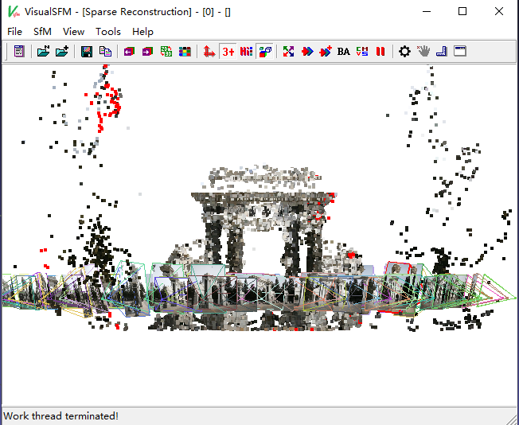

**Next week plan**

1. Continue to do finish 3D Reconstruction
2. Continue to read CVPR2019 paper